JWT Token
JSON web token
- Configure JWT based Authentication
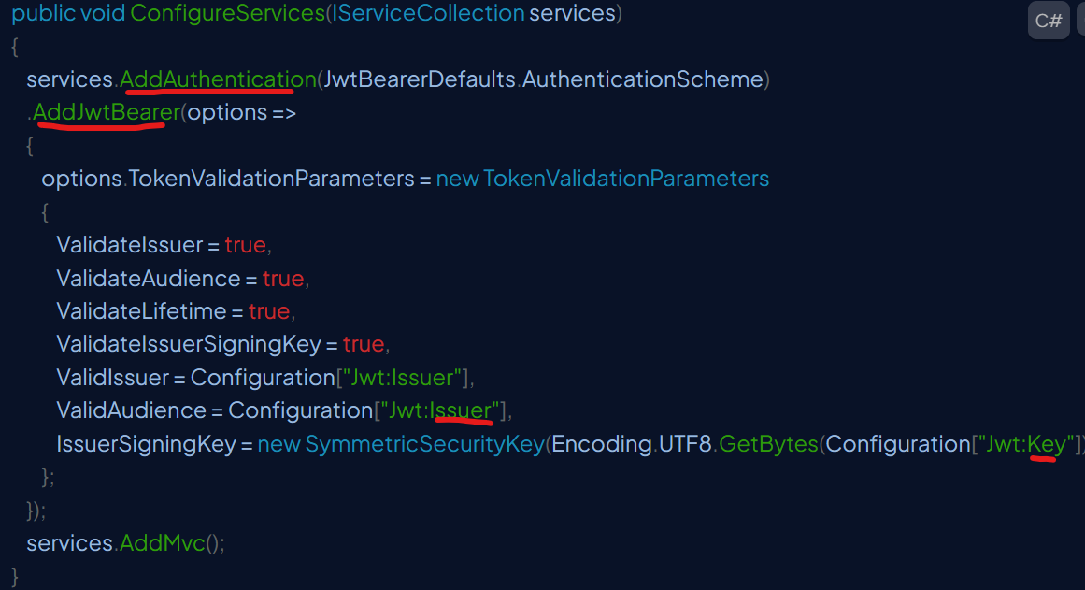
appSettings.json
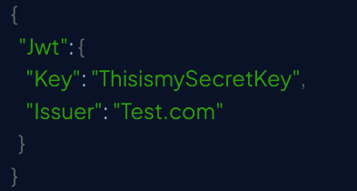
- Configure authentication middleware
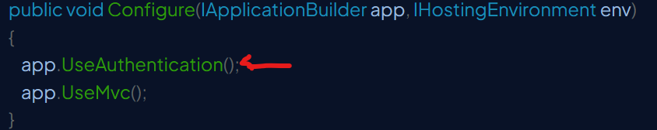
- Generate JWT token
In Login controller, create a Login method with Anonymous type and then Authenticate the logged in user, if a valid user, then Generate JWT Token.
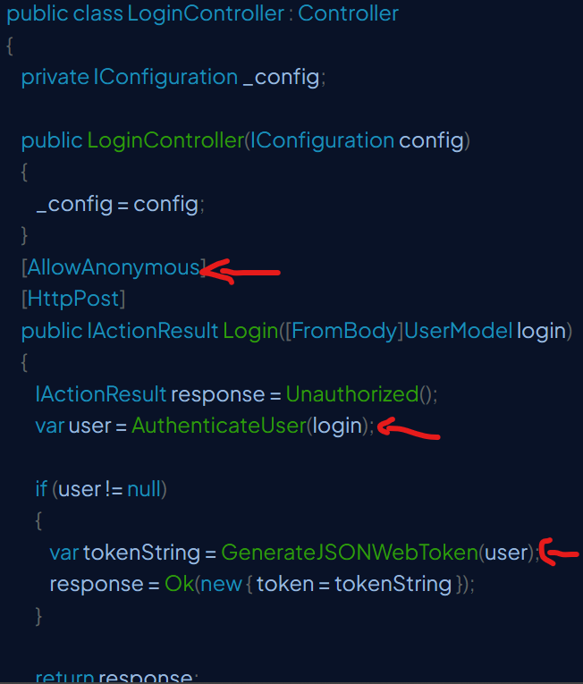
Get the key from appSettings Jwt key and use this key along with HmacSha256 algorithm to generate credentials.
Now, I had credentials, Jwt Issuer (defined in appSettings.json file), using both we are going to generate token.
Once key generated, we should writetoken using JwtSecurityTokenHandler method.
